

Dr. John, West inc.
2018-11-16
Dr. West
831 Michael Fork, Williamsonside, OK 22948
Phone: 392808752
Fax: 8200954077

Re: Michelle, Davis
PHN: 659393116
Birthdate: 21-Jul-2004
Address: 502 Nicole Ville Suite 620, Cummingsberg, CO 72513
Patient number: 5983887766

To Whom It May Concern:

This is a medical letter to state the above patient is pregnant with expected delivery date of 29-Apr-2025. Hoping this information is satisfactory for your requirements.

Thank you.

Sincerely,
Dr. John, West
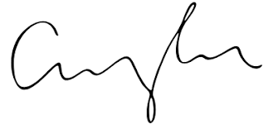
FRCS© NCMP
Clinical Assistant Professor, UBC
Department of Obstetrics and Gynecology SMH

